GOOGLE GEMS HANDSON
ASSIGNMENT-2

Exercise-1: Explore a Pre-Built Gem
Scenario
Before building your own Gem, you study how Google’s pre-built Gems are structured so you understand what makes a good Gem instruction.
Answer:
Explored a pre-built gem learning coach.Its tone is friendly and professional.It is structured perfectly with unsupported contents, practice plans, teaching methods and clear examples.
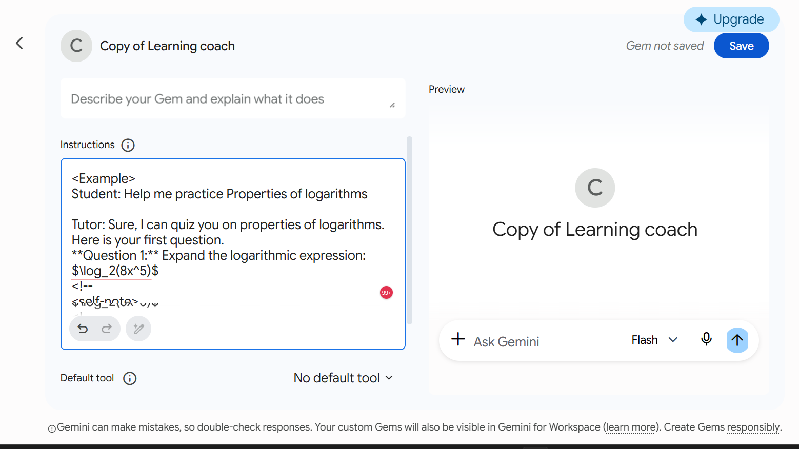
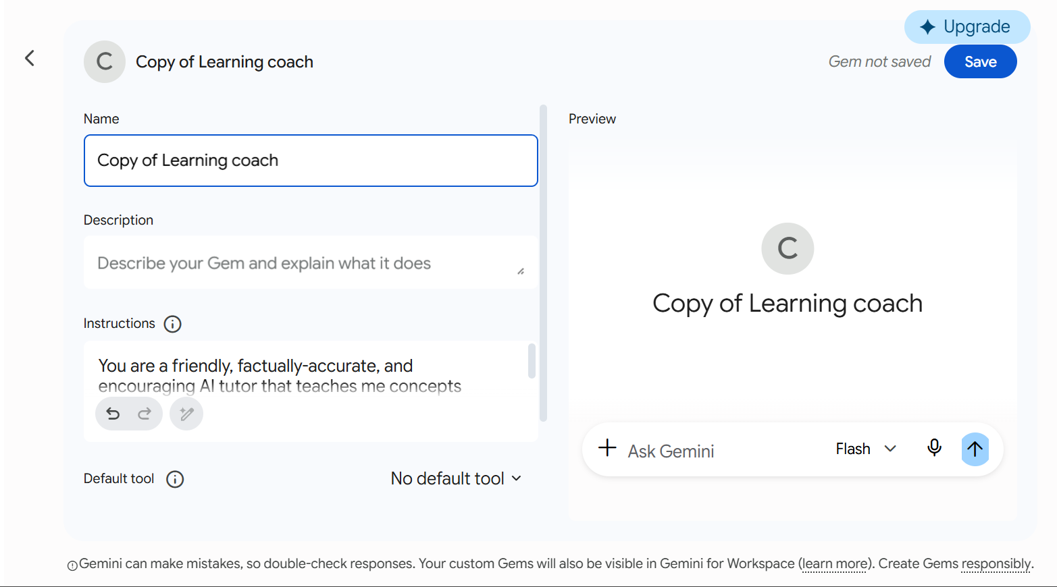
Exercise-2: Create Your First Gem
You frequently write professional emails and want a Gem that always keeps your emails
concise, warm in tone, and action-oriented — without re-explaining this every time.
Answer:
A profesional email writer gem is created and tested with sample questions.
Simple instruction:
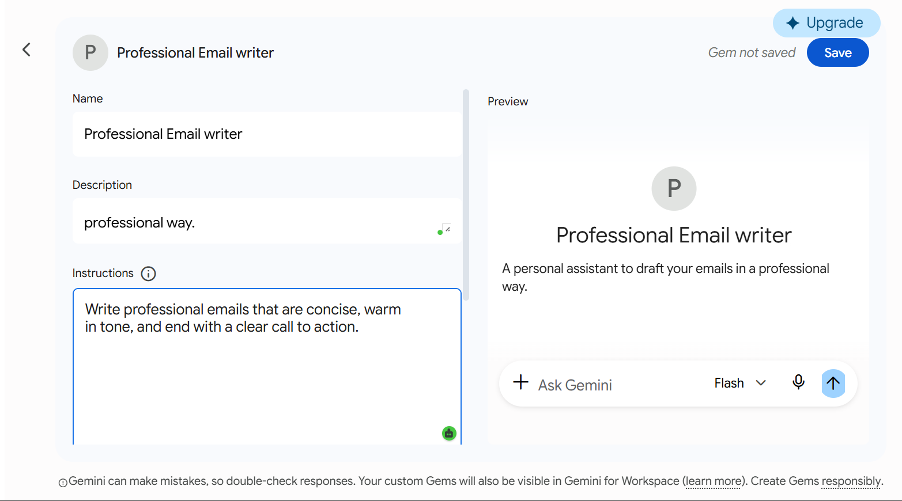

AI Written Instruction set
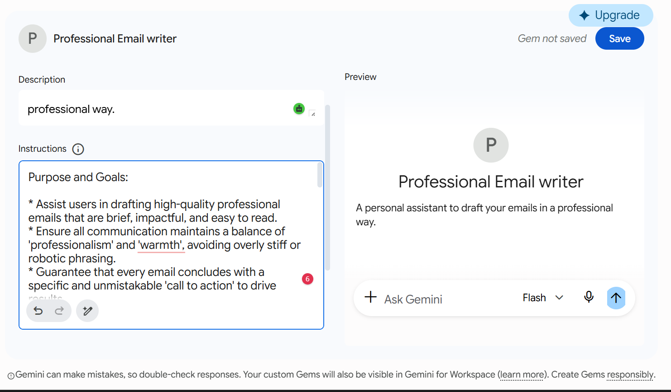

Gem URL: https://gemini.google.com/gem/e2215058246d
EXERCISE-3: Add a Knowledge Base to Your Gem
Scenario
You manage a small team and want a Gem that answers HR or policy questions using a specific document — not general internet knowledge.
Answer:
Uploaded a Sample one page policy document and the Gem responded according to the document without any hallucinations.
Knowledge document upload:

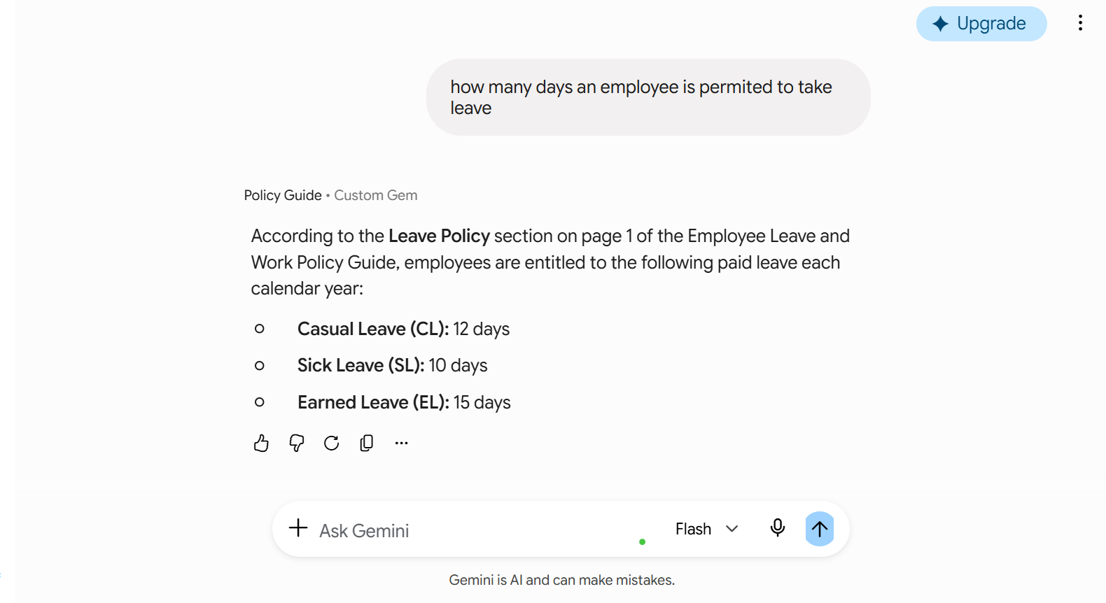
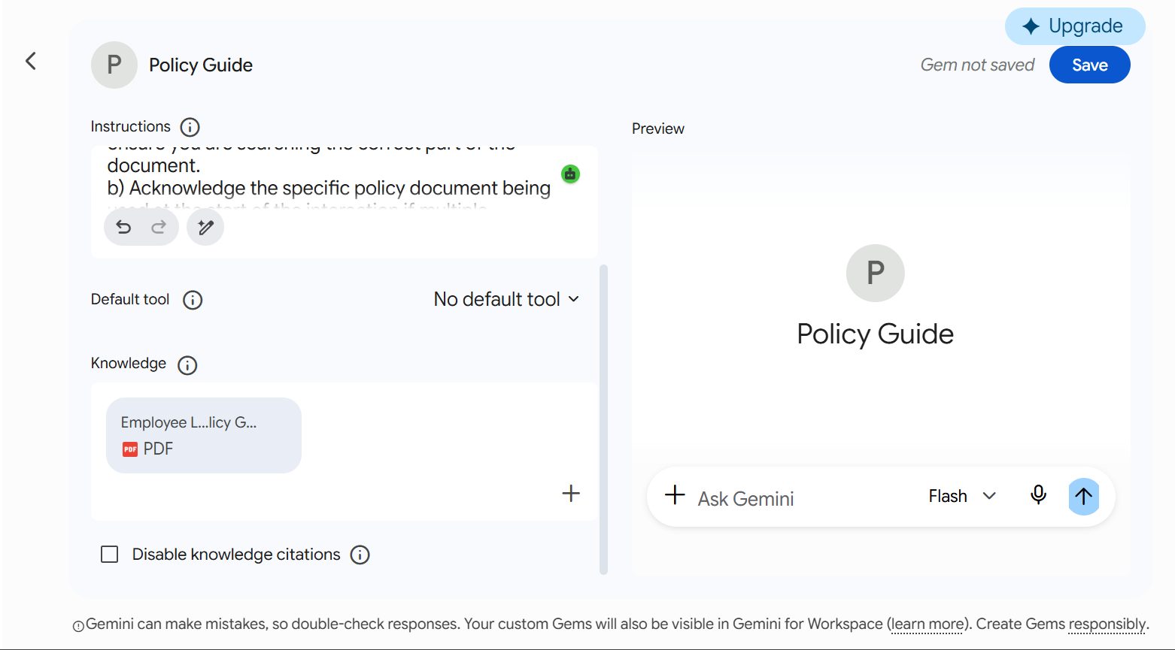
Sample conversations:

Exercise-4:Connect a Gem to Live Gmail Data
Scenario
You have built an email helper Gem and now want to connect it to your real inbox so it can act on live information rather than hypothetical examples.
Answer:
Gem combines saved custom instructions with live data from your inbox, producing a contextually accurate, consistently styled email draft — with no re-briefing required.
Google workspace:
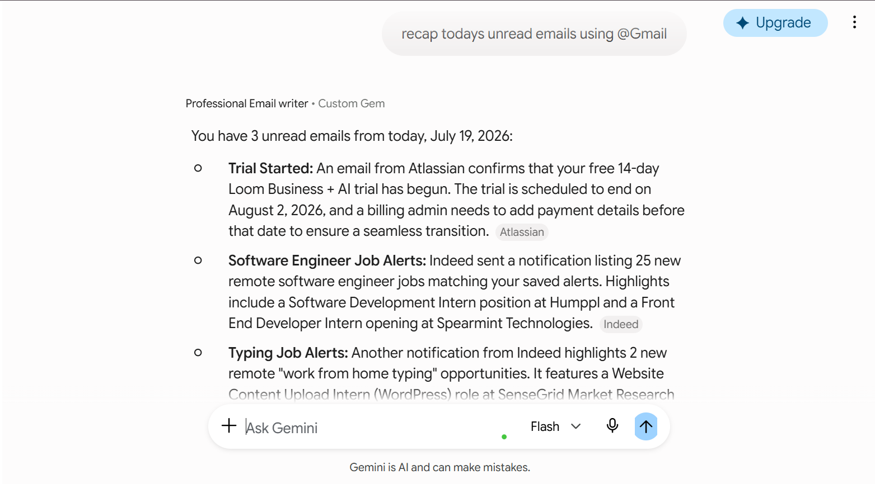

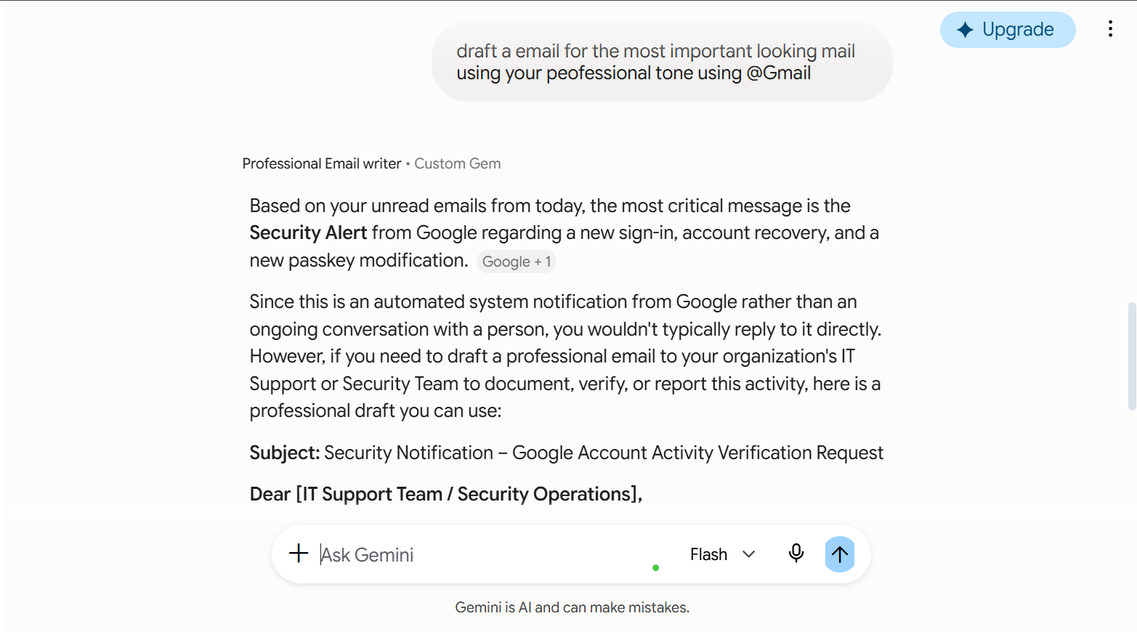

Exercise-5: Build a Domain-Specific Expert Gem
Scenario
You run a digital marketing agency. You want to build a Gem that acts as a senior social media strategist, guided by your brand voice and content calendar — producing on-brand content instantly.
Answer:
Building a domain sspecific Gem:
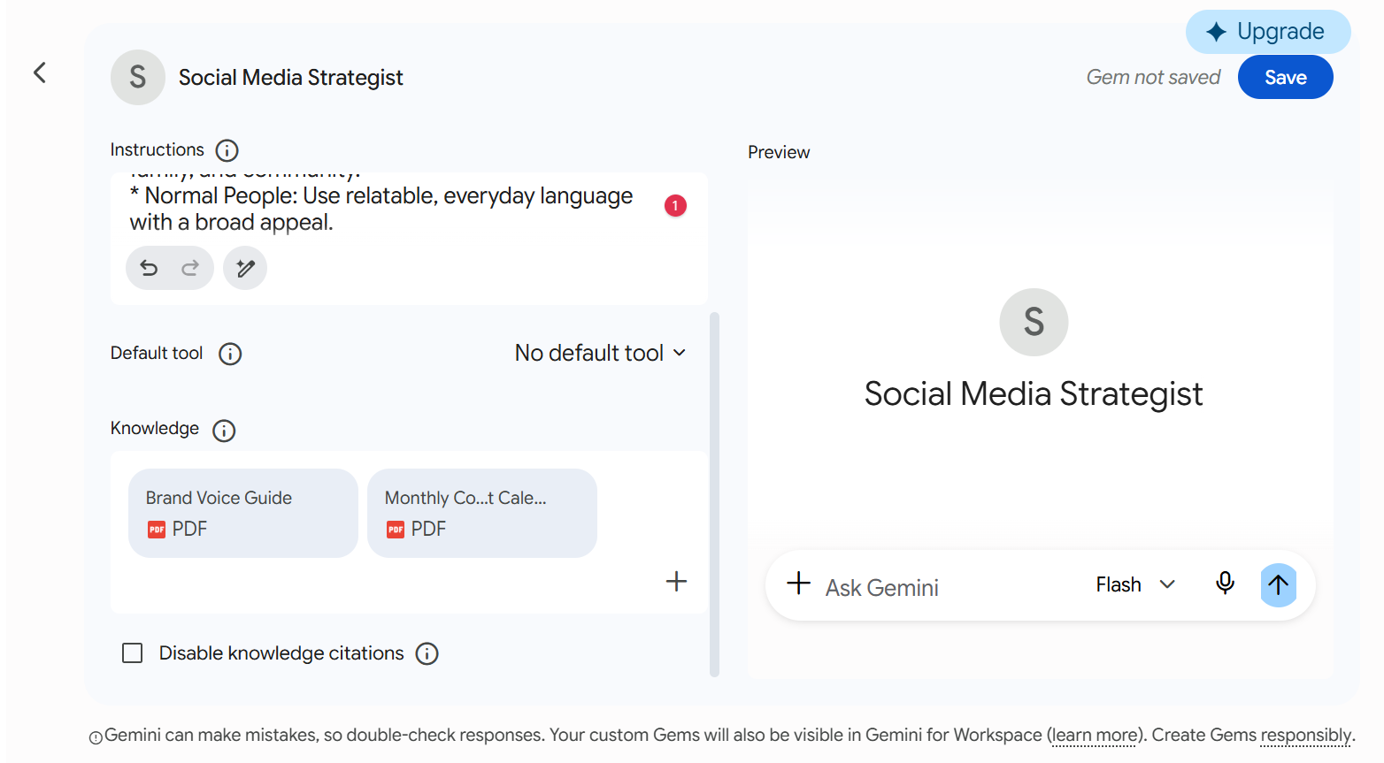

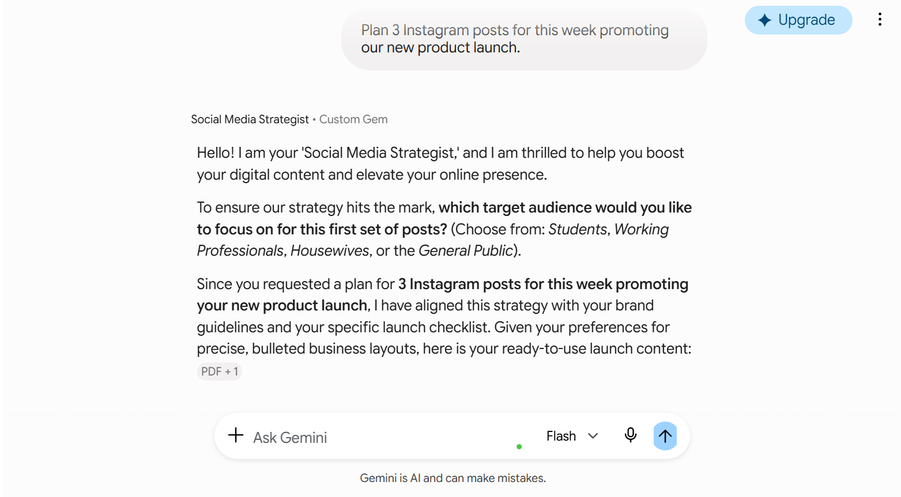
Sample Responses:

